All Saints CE Primary School and Nursery
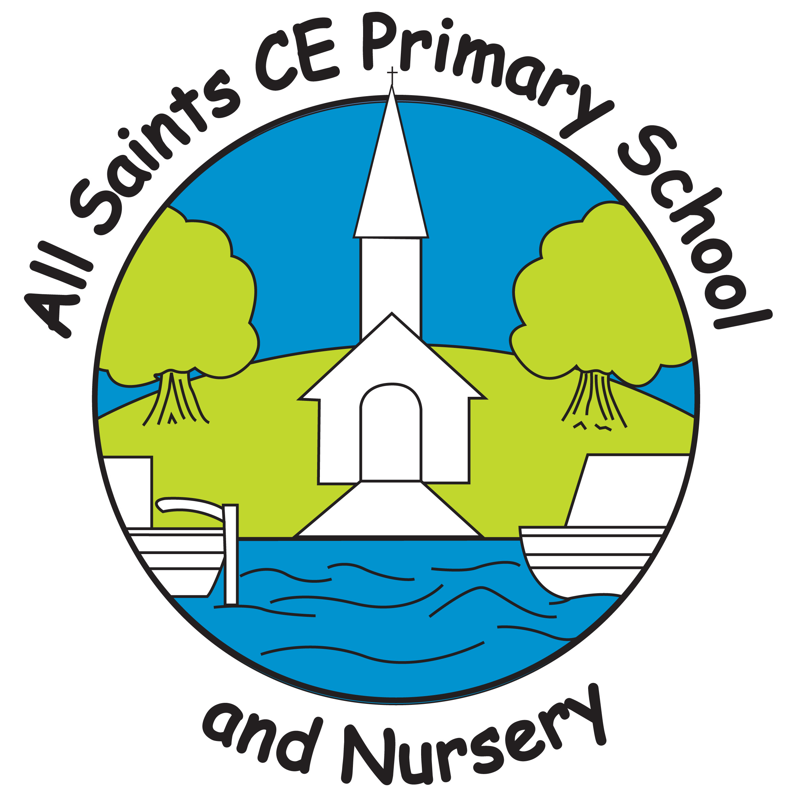

www.allsaintsceprimaryschoolandnursery.co.uk
A paper copy of this newsletter is available by contacting the school office.

Summer Term 2024 – Week Beginning 6th May 2024

 | “Change your hearts and lives and be baptized, each one of you, in the name of Jesus Christ for the forgiveness of your sins. And you will receive the gift of the Holy Spirit. 39 This promise is for you. It is also for your children and for all who are far away.”  Acts 2:38-41 Chosen by Year 4

Attendance and Punctuality for weeks beginning 29th April 2024
Attendance Pupils should attend school every day the school is open, unless they are really not well enough to. Please do not send children with a temperature over 38.
Attendance: | Year 1 96% | Year 3 96.3% | Year 5 95.4%
Reception 96% | Year 2 93.3% | Year 4 88% | Year 6 92.9%
Well done to Reception, Year 1 & Year 3 . They will receive 10 minutes extra playtime.
Whole School Attendance: 94% The school & national target is 96%
Punctuality The school gates open at 8:45am & close at 8:55am please arrive on time.
4 hours and 16 minutes of learning was lost last week due to children arriving late. Thank you to all of our families who are making an effort to arrive at school on time.

 | Year 6 SATs  Next week our Year 6 children begin their SATs week, they have preparing for this since September. All children are expected to take full advantage and attend the special FREE Breakfast Club on Monday to Thursday during SATs week. They will be given a ‘brain building breakfast’ and participate in ‘brain gym’ exercises. All Year 6 children need to arrive at school by 8 am on Monday 13th, Tuesday 14th, Wednesday 15th & Thursday 16th May. Children have completed regular SATs practices in test conditions so that they know what to expect. It is really important that they get plenty of sleep, and have lots of early nights for the next 2 weeks.

All Saints’ Vision and Values Award
At All Saints, our vision is Learning for life, building a firm foundation. We aim to give all children the best possible start in life and encourage the whole school community to be kind and forgiving towards one another. We aim to create a happy and caring atmosphere where children can learn, grow and develop together into independent and confident children ready to flourish and build their firm foundation for life.
We want to recognise the children who are working towards our school vision and are demonstrating our school Christian values. We present two weekly awards to two children in each class every week.
The Vision Award recognises children who have worked hard and are building their firm foundations in their learning or personal development.
The Values Award recognises children who are demonstrating our school values of Love, Truth, Faith, Hope or Peace.
Summer Term 1 week 4 All Saints Vision and Values certificates have been awarded to:
Vision Awards |  | Values Awards
Nursery | Freddie | Nursery | Layla-Jai | Love
Reception | Oliver | Reception | Edie | Love
Year 1 | Lyla | Year 1 | Ben | Faith
Year 2 | Nevaeh-Mai | Year 2 | Amaiya | Hope
Year 3 | Maria | Year 3 | Julia | Faith
Year 4 | Antonia | Year 4 | Max | Peace
Year 5 | Mark N | Year 5 | Harley | Peace
Year 6 | Charlie G | Year 6 | Alton | Faith
Have a look on the Vision & Values page of the website to see children receiving their certificates.



All Saints’ Happy Lunchtime Awards
Well done to the children who have shown our school values at lunchtimes last week.
Mrs Hyde | Thierry |  | Mrs Lusty & Miss Rouse |  | Joseph
Mrs Powell | Maria |  | Mrs Fyfe |  | Isaac
Miss Lodge | Raheeb |  | Mrs Clarke |  | Dima
Mrs Patel | Charlie T |  | Miss Edwards |  | Alisha
Mrs Reid | Ben |  | Mrs Paradowska |  | Lena
Miss Dodd | Archie |  | Mrs Smith |  | Emilie-Rae
The classes winning the PomPom Challenge and being awarded with the Golden Lunchbox are:
 |  | Year 2
Every single class has done really well this week and the PomPoms have been over spilling! Well done to each and every one of you who has been POMtastic this week!

Art Gallery Day  You are invited to our whole school Art gallery morning on Tuesday the 4th of June. Doors will open at 9.30am and will close at 10.30am. This is a drop in session, in the hall, that will display Artwork from each class, linked to their current topic/focus Artist. During the Art gallery, an Art raffle will also take place where many Art and Craft materials are up for grabs! Tickets will be £1 per strip. Get your raffle tickets at the ready | 
, come, and be inspired by the Artists of All Saints! We look forward to seeing you there. If you have any further questions, please see Miss Lomas who is happy to help you.

 | All Saints Voices  To celebrate their achievements in choir, All Saints Voices would like to invite their parents and carers to a small concert to showcase their songs. The concert will be held on Wednesday 22nd May at 4pm, for approximately half an hour. We look forward to singing for you.

Before & After School Care  After the Bell is our paid for after school child care provision. It is available for children in Reception through to Year 6. If you would like to book your child in to our before school club (Breakfast Club) or after school club please contact the school office to book them in. More information can be found by visiting our website: https://www.allsaintsceprimaryschoolandnursery.co.uk/beforeandafterschool | 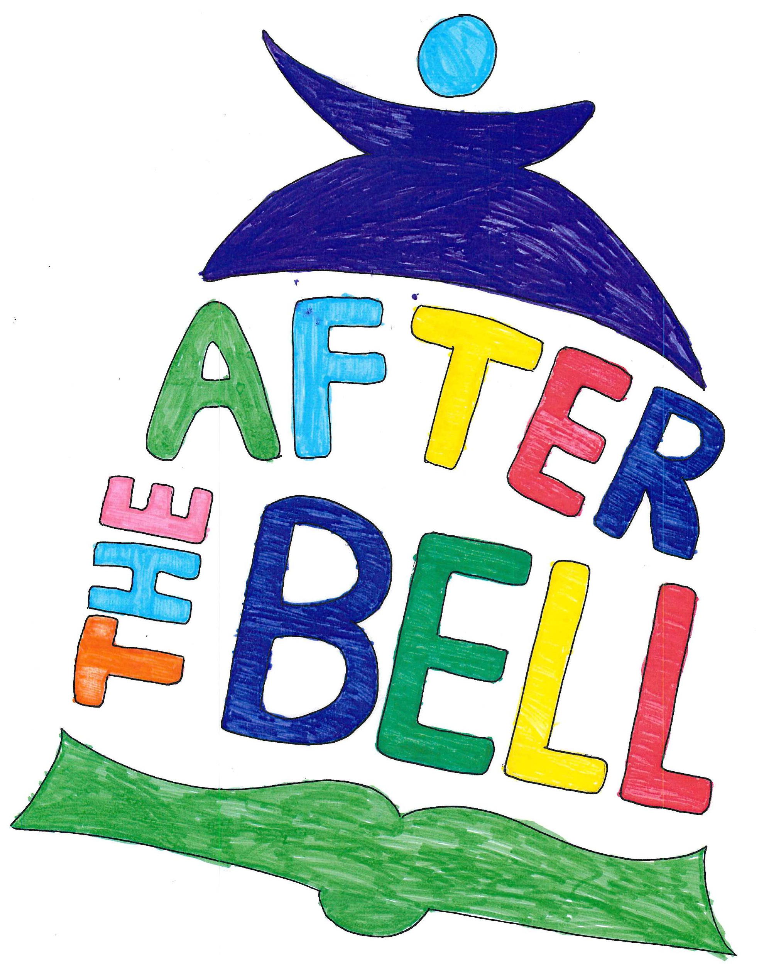

 | All Saints’ Vision  We live, learn and grow by following the wise builder’s example. This inspires us to listen to guidance and learn from mistakes. At All Saints, we prioritise building self-esteem so that everyone can flourish. Upon firm foundations, we live learn and grow together, no matter where our journeys start.

 | 

Do you have a pre-school child?  Did you know that if you have any questions or queries about your child’s language development, you can make an appointment to have an informal chat with a speech and language therapist? To make an appointment you can | 
telephone the speech and language department on 02476378620 and ask for ‘an appointment for a drop-in session’. This will take place in Nuneaton and is a free service.

Important Dates for your Diary 2024
Monday 6th May |  |  | Bank Holiday – School Closed to all
Monday 13th – Thursday 16th May |  |  |  | Key Stage 2 SATs week 8am FREE Breakfast Club
Monday 20th May |  |  | Art Week
Tuesday 21st May |  | Sports Day at Pingles Stadium (Years , 4,5 & 6 am, Years 1,2 & 3- pm)
Thursday 23rd May |  |  | EYFS (Nursery & Reception) Sports Day 9:30am
Thursday 23rd May |  |  |  |  | Year 5 Class Assembly 2.30pm NEW DATE
Thursday 23rd May |  |  | Year 6 in school Djembe music workshop
Friday 24th May |  |  | Waste Free Lunch assembly
Monday 27th – Friday 31st May |  |  |  |  |  | May Half Term
Monday 3rd June |  |  | Teacher Training Day – School Closed to all children
Tuesday 4th June |  |  | Children return to school for Summer term 2
Tuesday 4th June |  |  | All Saints Art Gallery 9:30 – 10:30am
Monday 17th June – Friday 21st June |  |  | Hunts Summer Term Book Fair in the hall from 3.20pm until 3.50pm every day. Card payments accepted.
Friday 5th July |  |  | Topic Day – more details to follow
Wednesday 10th July |  |  | Induction Day
Thursday 11th July |  |  | Year 3 Ancient Egyptians Trip to Leicester Museum
Friday 12th July |  |  | Topic Day – more details to follow
Tuesday 16th July |  |  | Coram Visit
Tuesday 16th July |  |  | Year 6 Music Concert in Warwick – more details to follow
Wednesday 17th July |  |  | Year 6 Class Assembly 2pm
Thursday 18th July |  |  | DT Day
Friday 19th July | Last day of Summer Term, children break up for the Summer Holidays
Monday 2nd September |  |  | Teacher Training Day – School Closed to all children
Tuesday 3rd September |  |  | All children return to school for the new school year.
Friday 25th October |  |  | Teacher Training Day – School Closed to all children
Am I eligible for Free School Meals? Call 01926 359189
School Nurses text messaging number: 07520619376
https://parentingsmart.place2be.org.uk/ Practical advice for parents
Find us on Twitter - https://twitter.com/AllSaints_Nun 

Measles  There are still cases of measles. Please ensure you remain vigilant.  If your child has not had their MMR Vaccination and you would now like them to, or you are | 
unsure if they should, please contact your GP to get this booked in or to discuss the vaccination with a medical professional.

 | If you have concerns that a child is suffering any form of abuse, neglect or cruelty contact the Warwickshire Children and Families Front
Door (Front Door) immediately by calling 01926 414144. Lines are open Monday to Thursday 8.30am - 5.30pm, Friday 8.30am - 5.00pm. If you need to get in touch out of usual office hours, please contact the Emergency Duty Team immediately by calling 01926 886922. If you think that a child is at immediate risk, call 999.





